厦门迪太进出口有限公司
XIAMEN DITAI IMP.& EXP. CO.,LTD
地址：中国厦门禾祥西路鸿升大厦8A
8FL, Hongsheng Building, West Hexiang Road, Xiamen, Fujian, China
TEL:0592-26808108 Phone:+8615160094689 FAX:0592-2680880 E-mail: irene.zhang@xmditai.com
----------------------------------------------------------------------------------------------------------------------
Animal Bone Ash
Animal Bone Ash details
Bone ash is a white bone piece or powder. It is derived from degreased animal bone with temperature burning by 1300℃
It is widely used in porcelain industry to produce bone china and metallurgy industry,even used as a polishing agent, paint stabilizer,syrup clarifying agent.
The product in the entire production process, after several high temperature treatment, without adding any chemical treatment and made. The products are mainly used in advanced ashes ceramic production materials, metallurgical release agent.
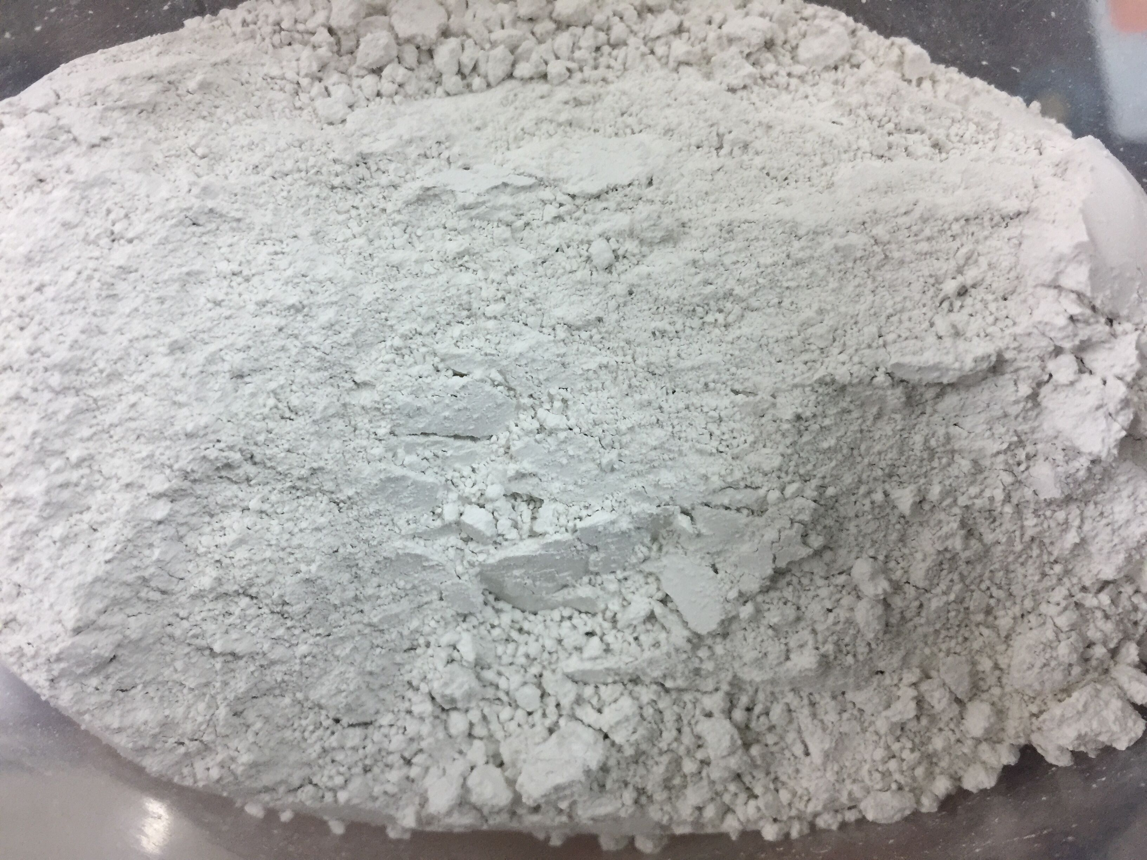

Animal Bone Ash Specifications as follow:

P2O5:≥40%；
CaO:≥50%;
Ash content:≤10%
Ignition losses :≤0.8%
Whiteness: 80

