厦门迪太进出口有限公司
XIAMEN DITAI IMP.& EXP. CO.,LTD
地址：中国厦门禾祥西路鸿升大厦8A
8FL, Hongsheng Building, West Hexiang Road, Xiamen, Fujian, China
TEL:0592-26808108 Phone:+8615160094689 FAX:0592-2680880 E-mail: irene.zhang@xmditai.com
----------------------------------------------------------------------------------------------------------------------
Burning Magnesium Oxide
Burning Magnesium Oxide Caustic Calcined Magnesite
It is made from magnesite ore as raw material, by calcining in rotary kiln, manufactured after fine grinding, stable quality performance, high purity, good activity. It is extensively applied to produce refractory materials, chemical engineering, building material and paper making industry, etc.
Burning Magnesium Oxide Description
Magnesium oxide is white or light yellow powder. It is tasteless, nontoxic amorphous.
It is slightly soluble in white and organic solvents, and soluble in acid or salt solution.
Burning Magnesium Oxide Packing
1MT/net by PP bags , 1.25MT/net by PP bags or as per customer's request.
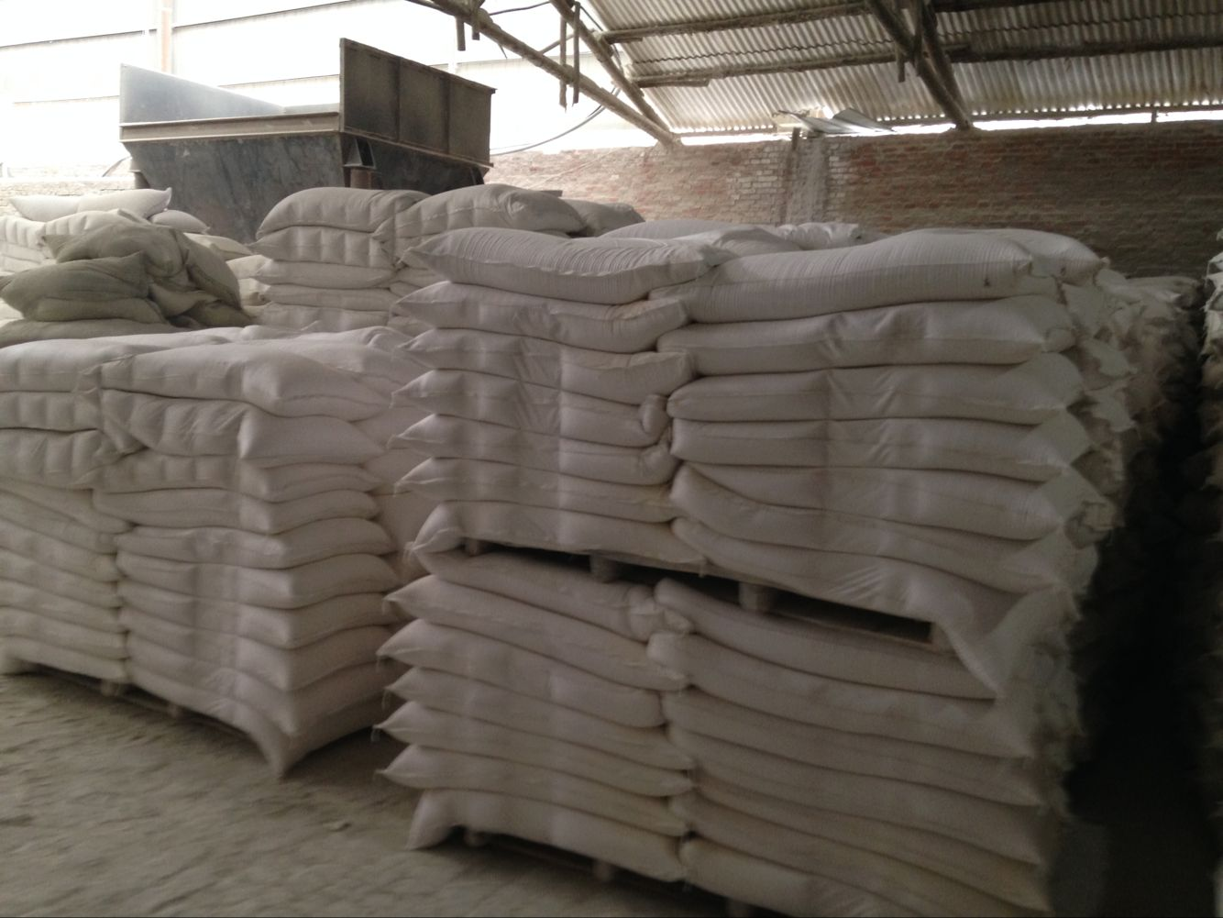
Burning Magnesium Oxide Description Capacity
18MT/20MT/25MT into one 20 FCL
